**Sa1 fault on Phase A**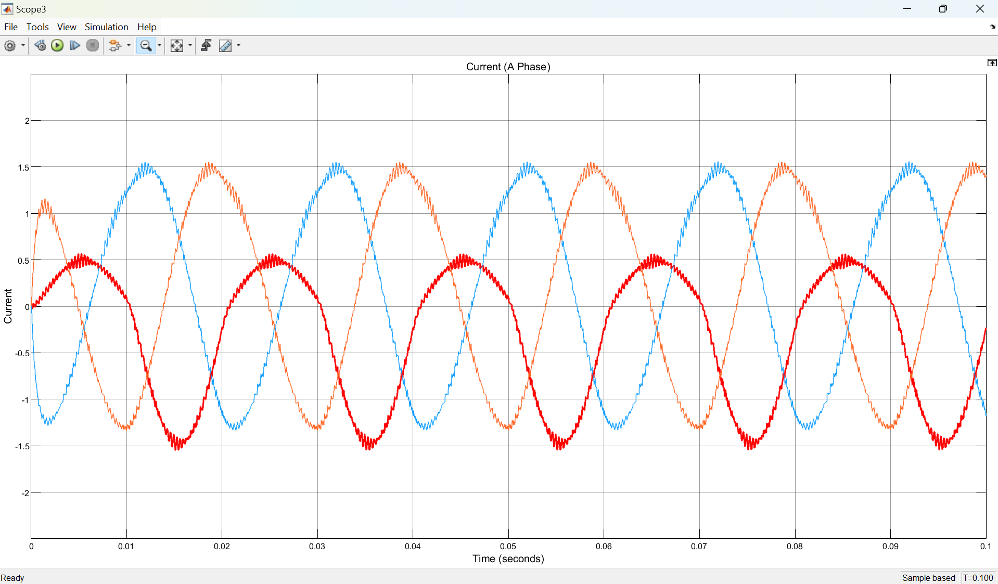

**Sa2 Fault on Phase A**

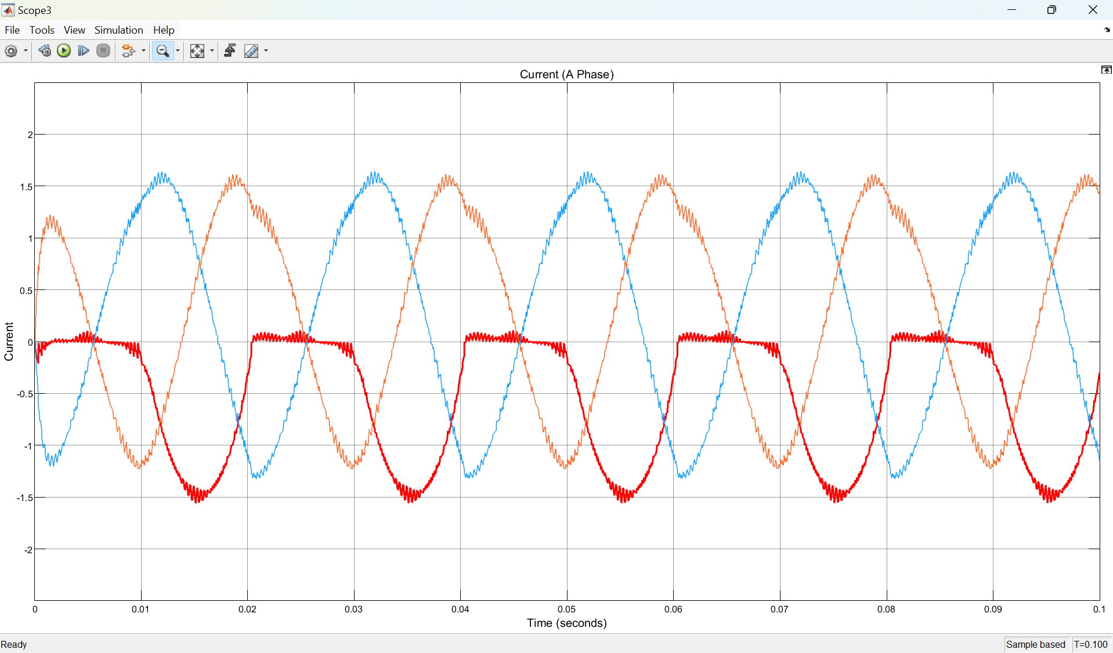

**Sa3 Fault on Phase A**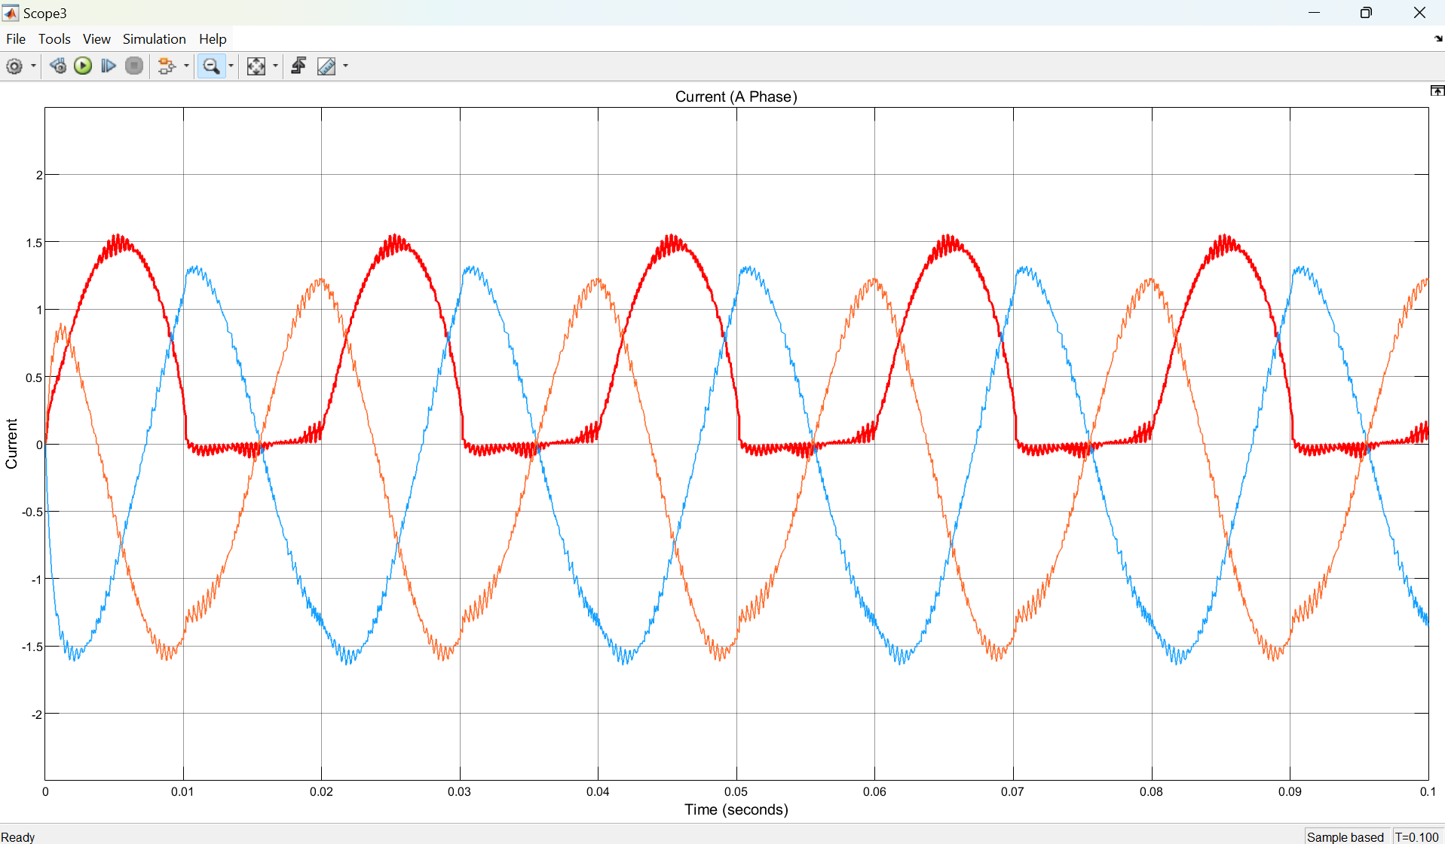

**Sa4 Fault on Phase A**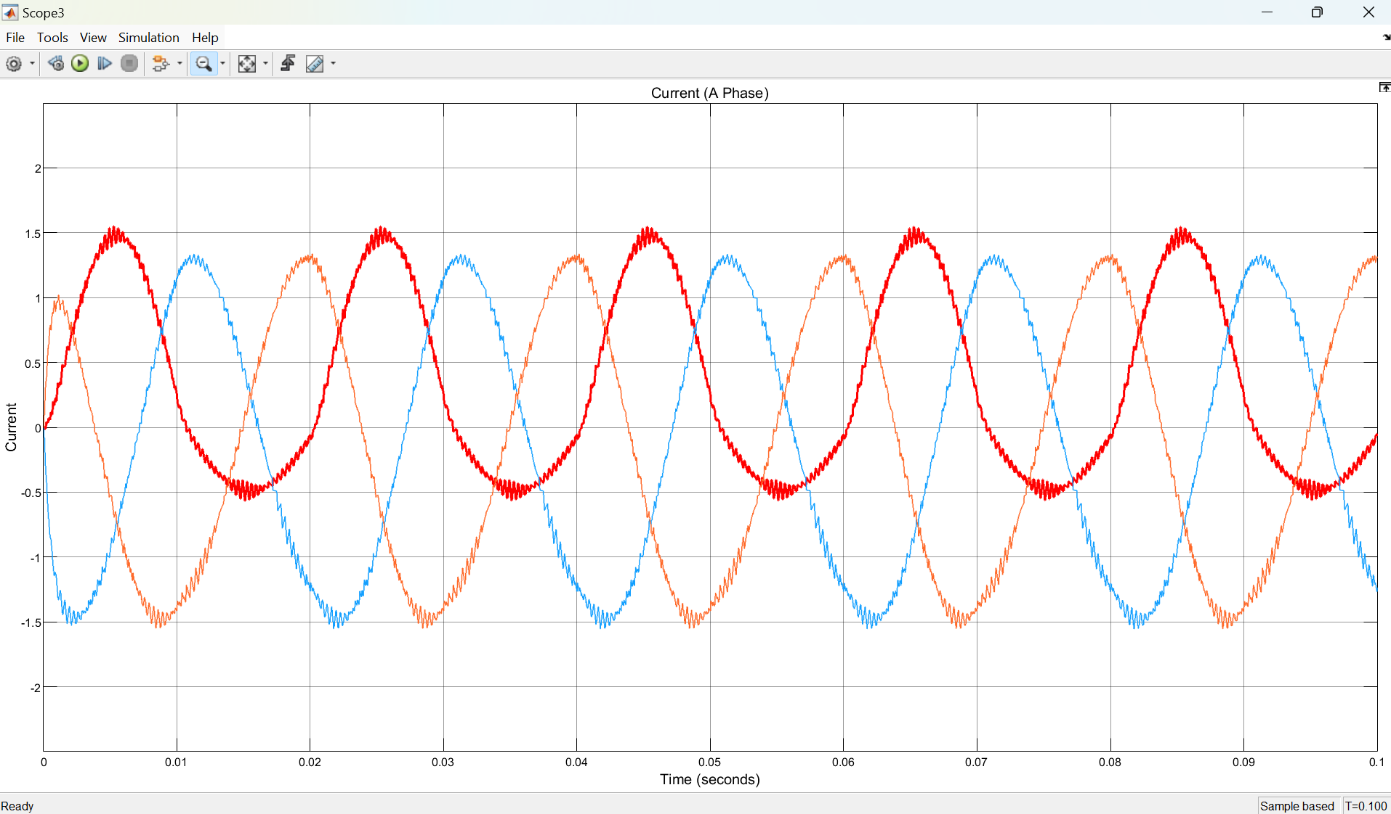

**Sa1 Fault on Phase B**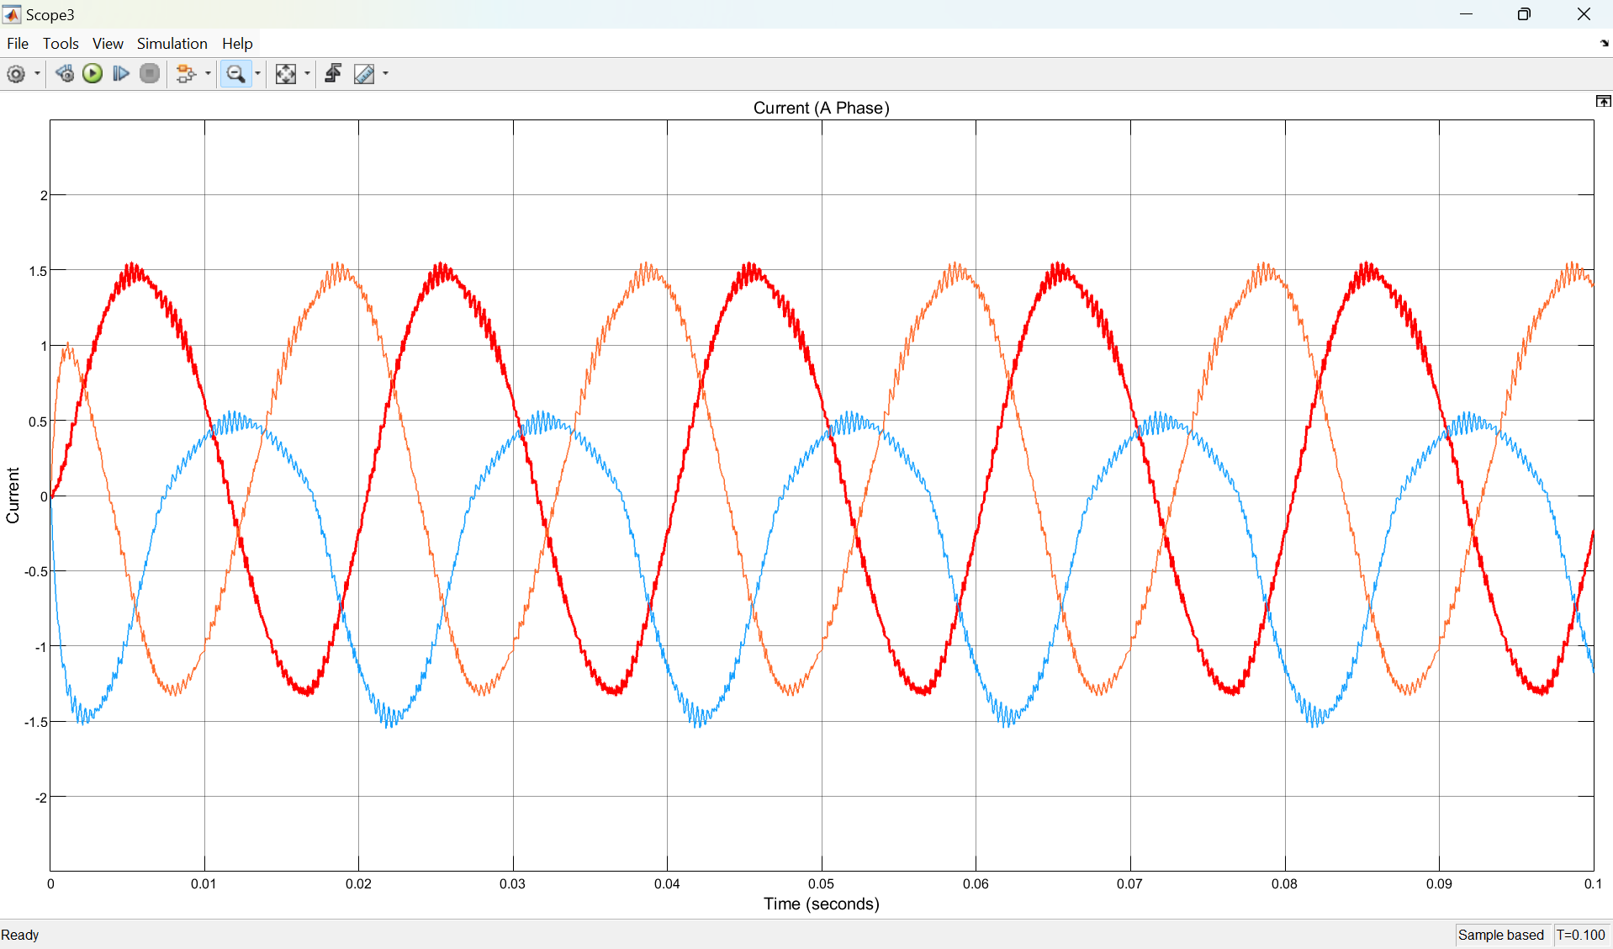

**Sa2 Fault on Phase B**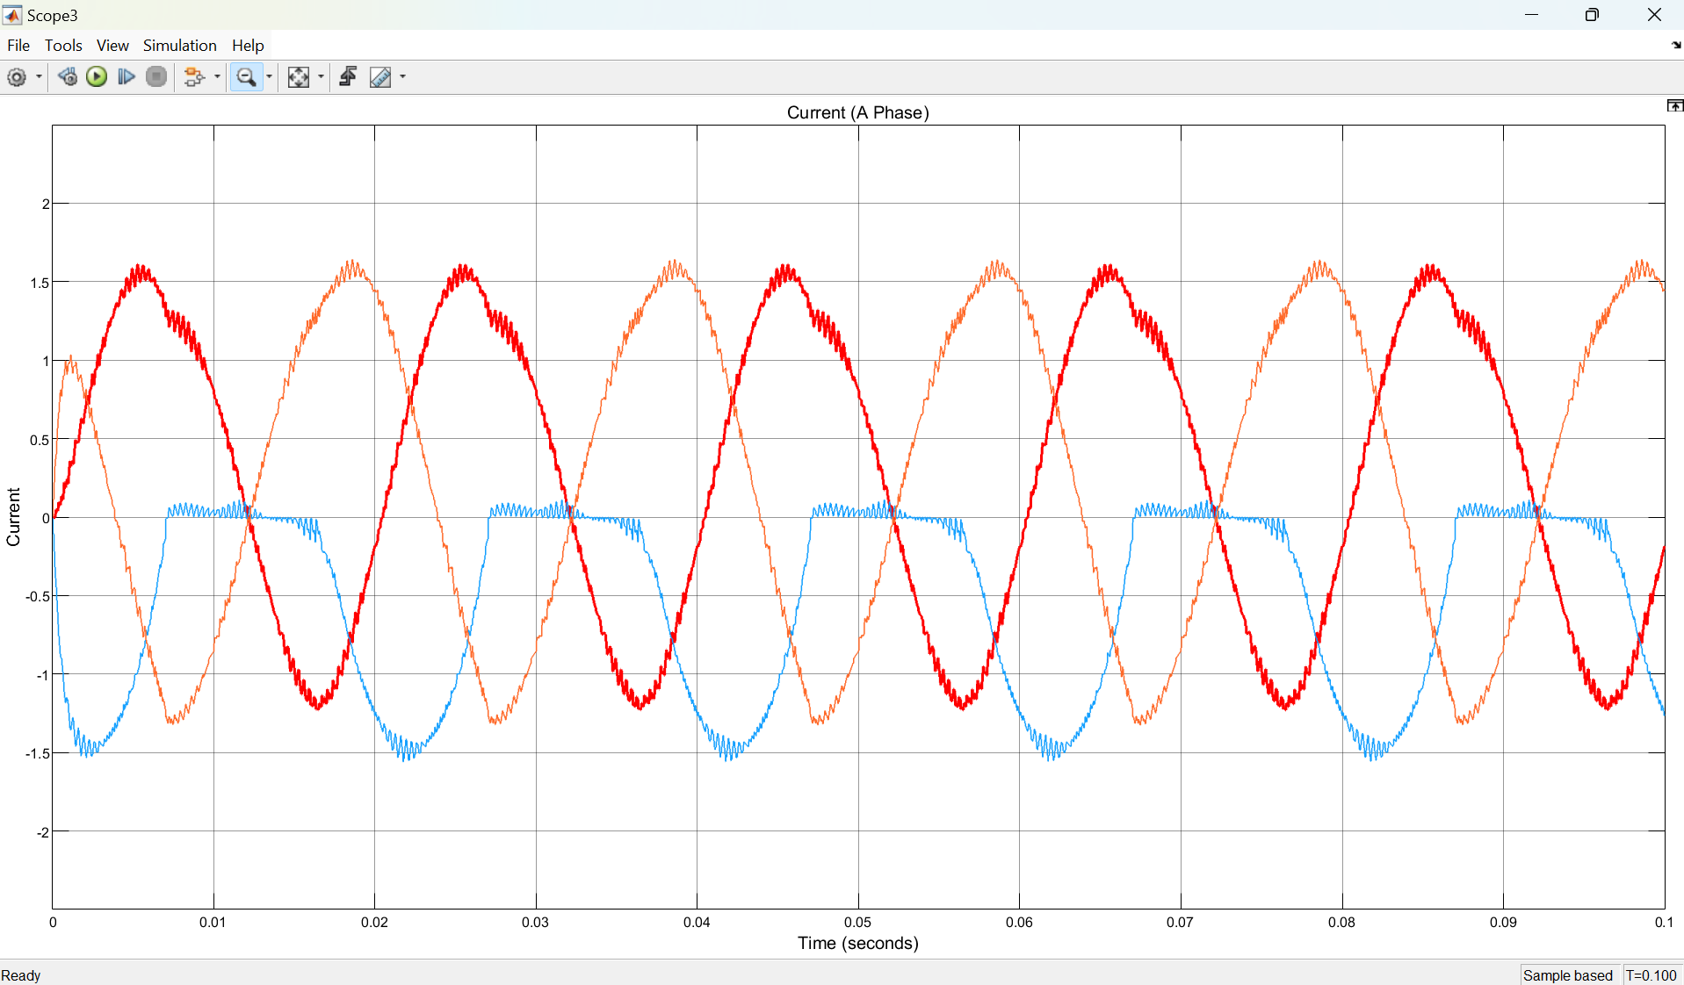

**Sa3 Fault on Phase B**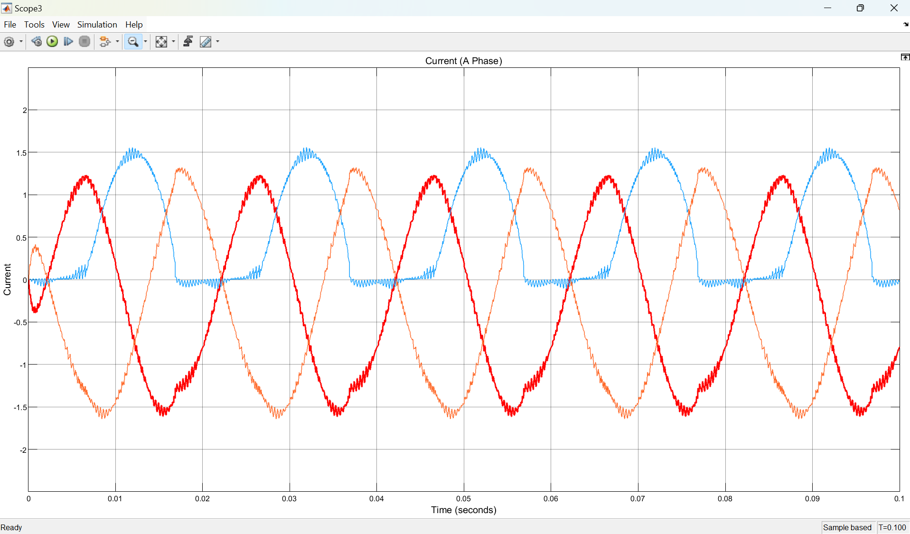

**Sa4 Fault on Phase B**